Practice-5 rollno:2520030022 name:AVSNRAkhila
STEP 1: CREATE TABLES
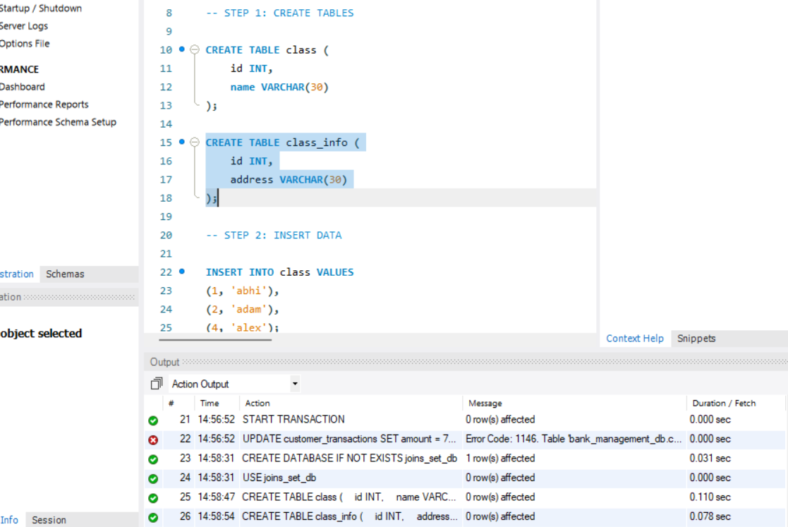
STEP 2: INSERT DATA
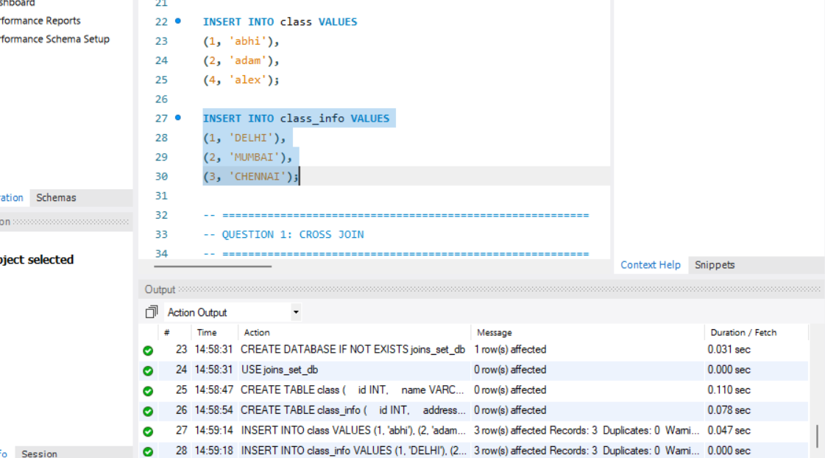
QUESTION 1: CROSS JOIN
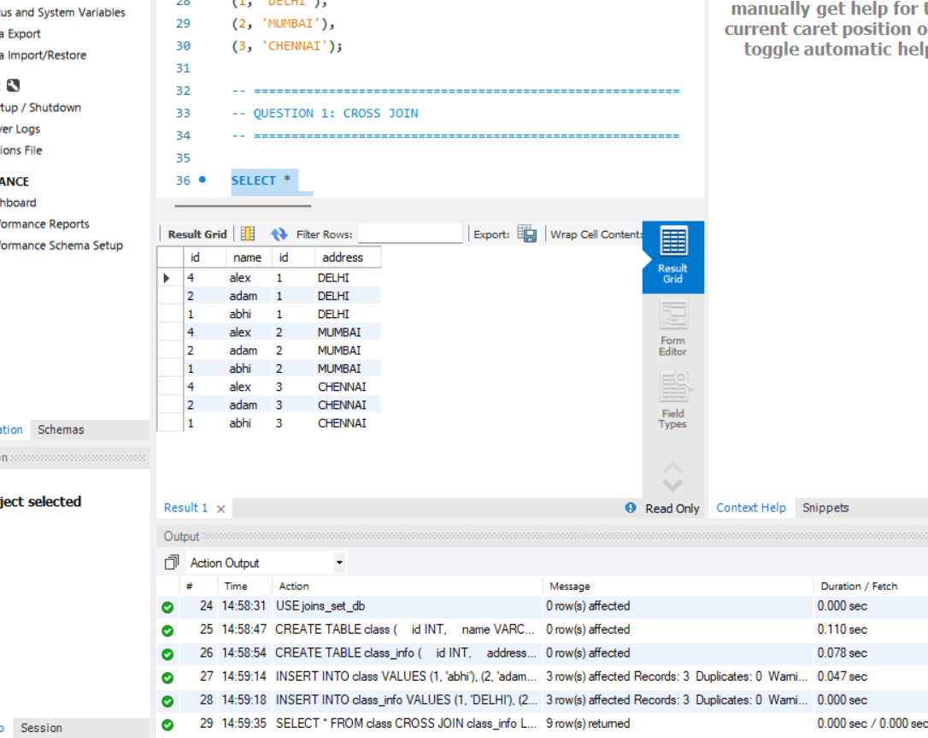
PART 2: INNER JOIN
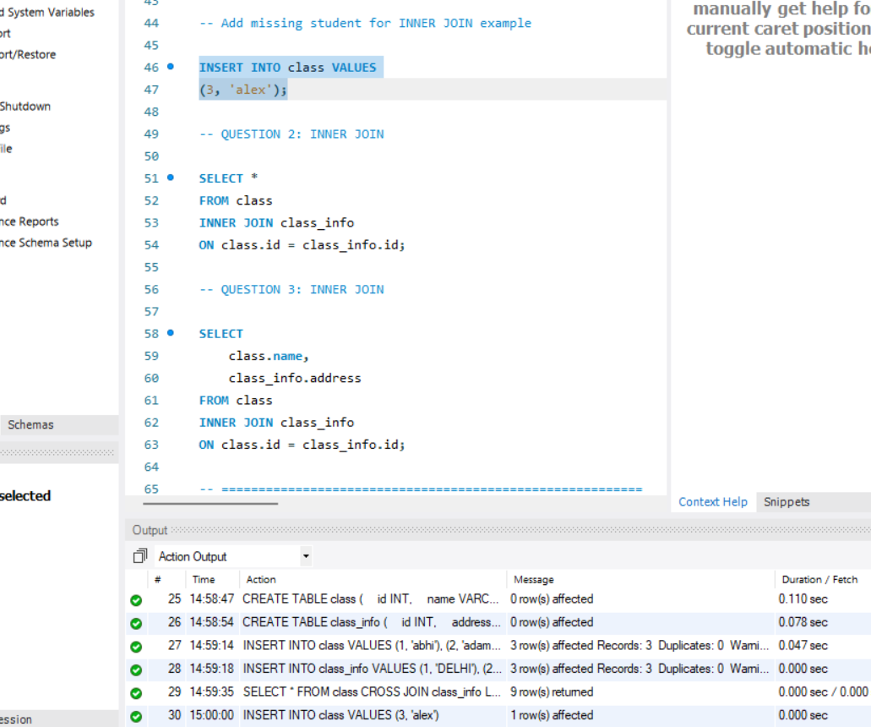
QUESTION 2: INNER JOIN
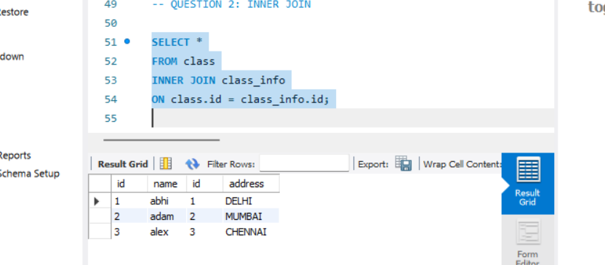
QUESTION 3: INNER JOIN
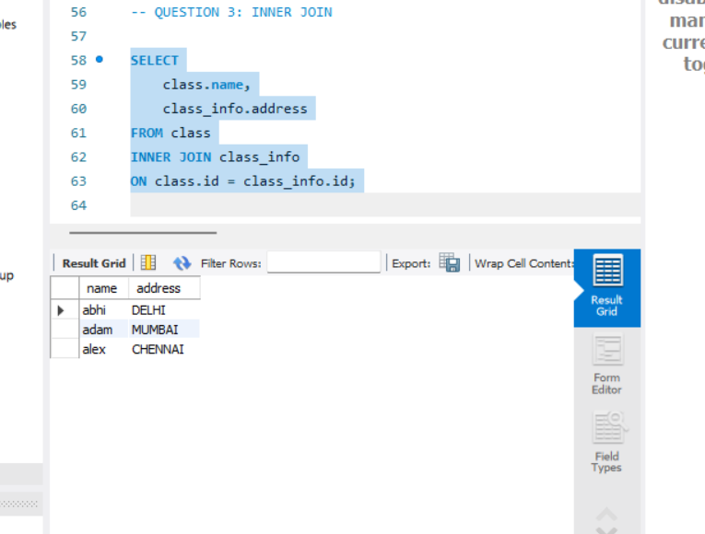
QUESTION 4: NATURAL JOIN
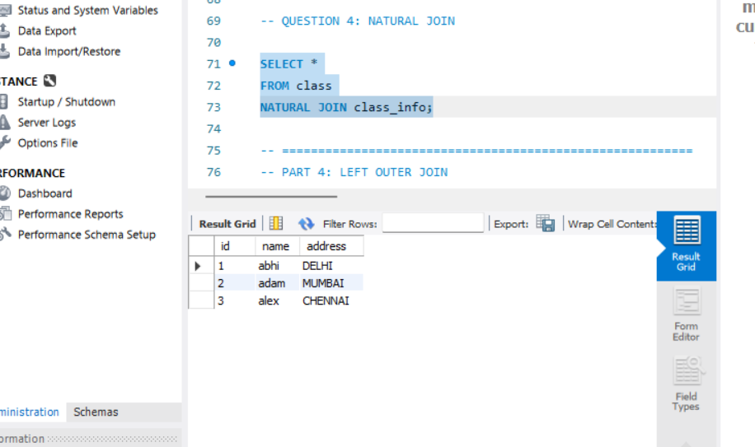
PART 4: LEFT OUTER JOIN
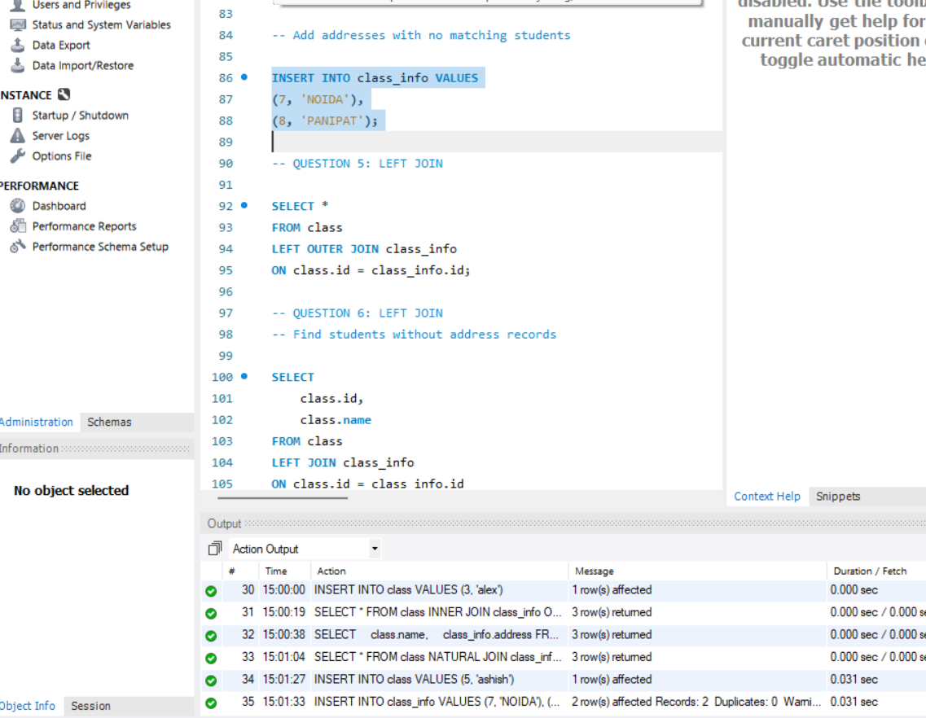
QUESTION 5: LEFT JOIN
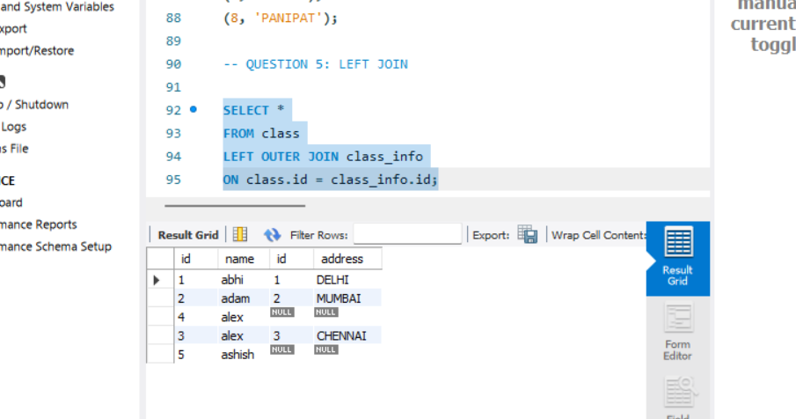
QUESTION 6: LEFT JOIN
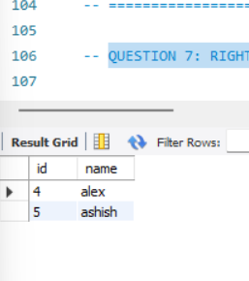
QUESTION 7: RIGHT JOIN
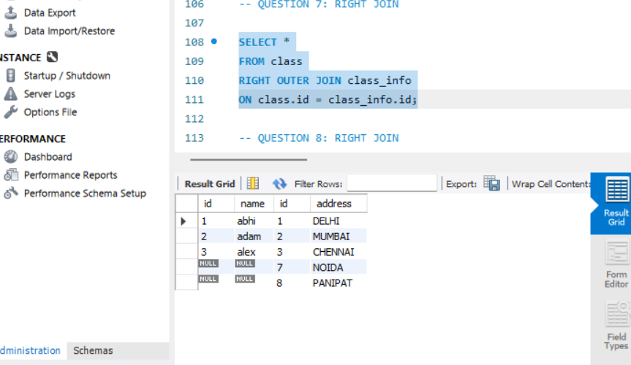
QUESTION 8: RIGHT JOIN
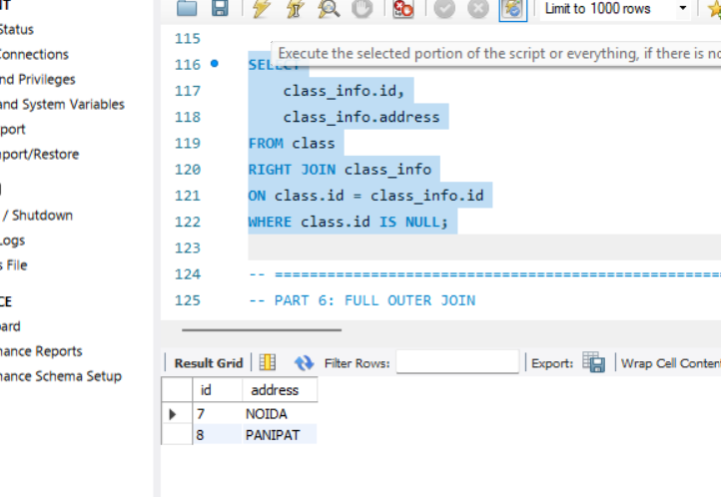

QUESTION 9: FULL OUTER JOIN equivalent
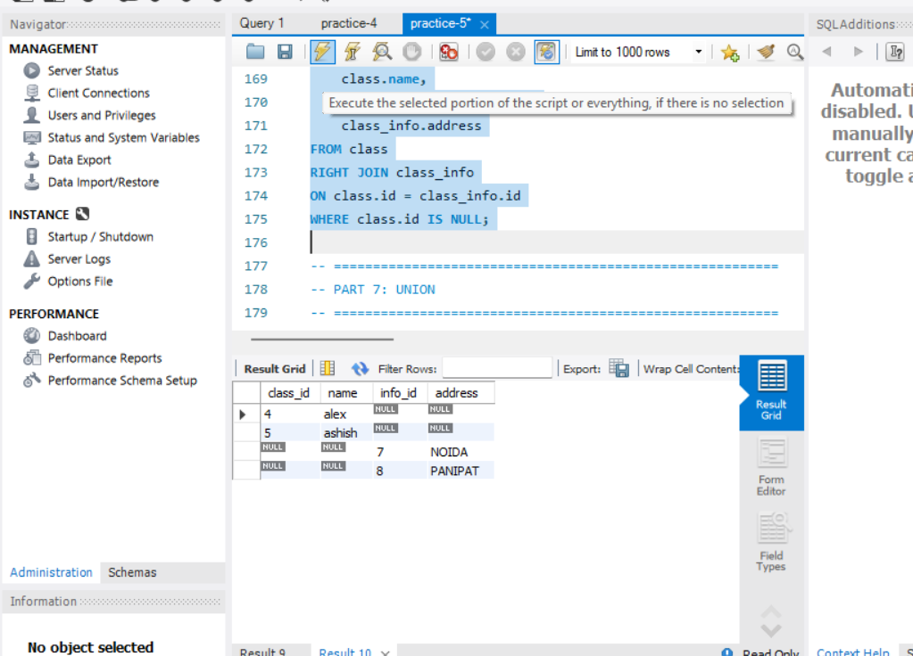
QUESTION 11: UNION
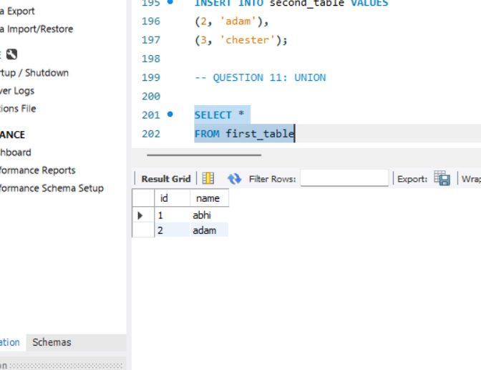
QUESTION 12: UNION
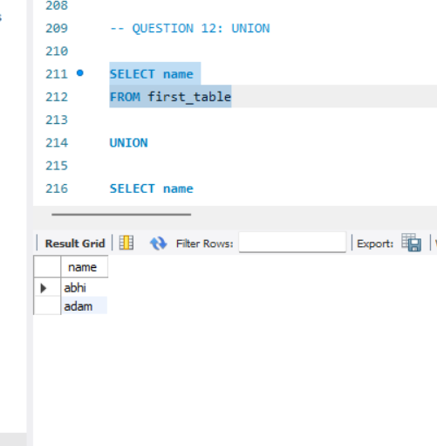
QUESTION 13: UNION ALL
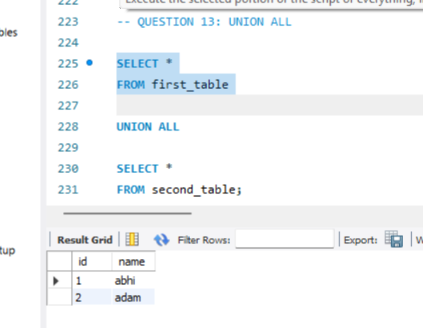
QUESTION 14: INTERSECT
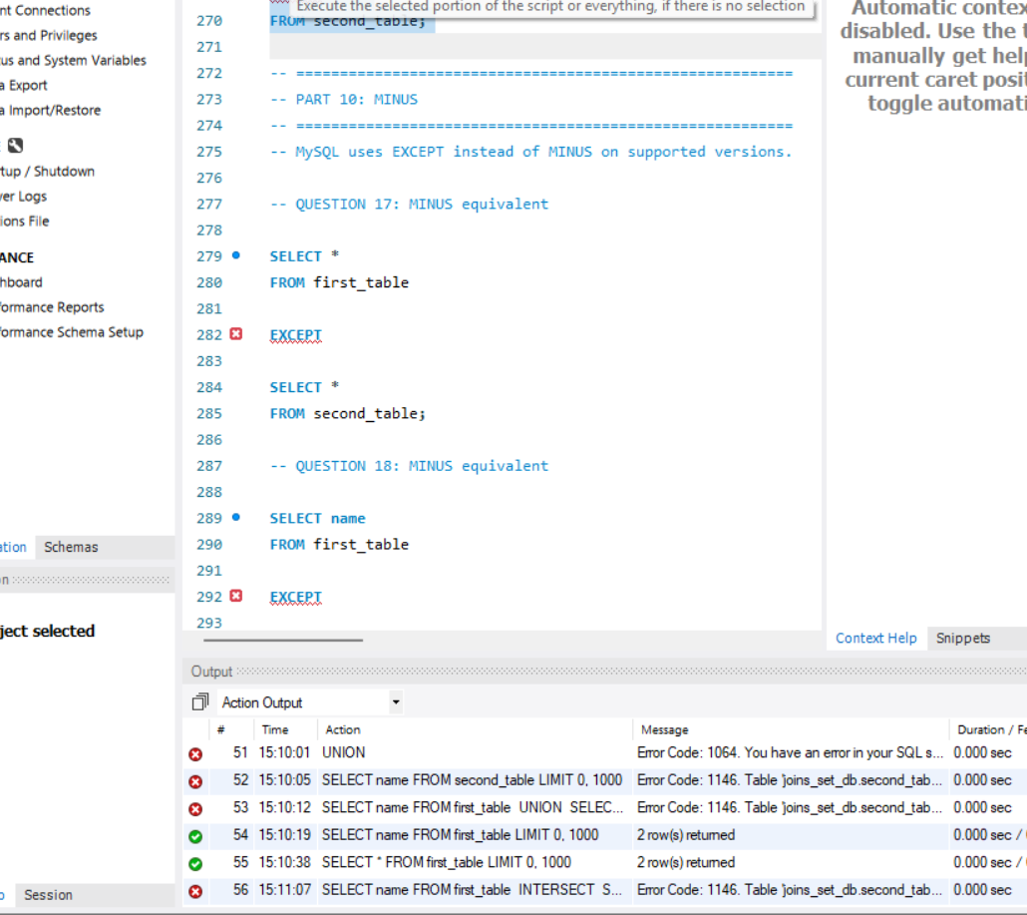
QUESTION 15: JOIN + CASE

